**Annenberg School Not Interpolated Old Data**

Learning Regression Tree...

Elapsed time is 0.365050 seconds.

Training RMSE(W): 2.96, R2: 0.909, RMSE/peak: 0.0327, NRMSD: 4.23

Learning a cross validated tree...

Elapsed time is 3.083887 seconds.

Cross Validated Training RMSE(W): 4.38, R2: 0.801, RMSE/peak 0.0483, NRMSD: 6.26

Learning a Random Forest...

Elapsed time is 109.825399 seconds.

Random Forests Training RMSE(W): 3.23, R2: 0.892, RMSE/peak 0.0356, NRMSD: 4.62

Testing RMSE(W): 13.88, R2: 0.000, RMSE/peak: 0.1548, NRMSD: 23.06

Cross Validated Testing RMSE(W): 13.42, R2: 0.000, RMSE/peak 0.1497, NRMSD: 22.30

RF (Testing) RMSE(W): 12.24, R2: 0.000, RMSE/peak 0.1366, NRMSD: 20.34

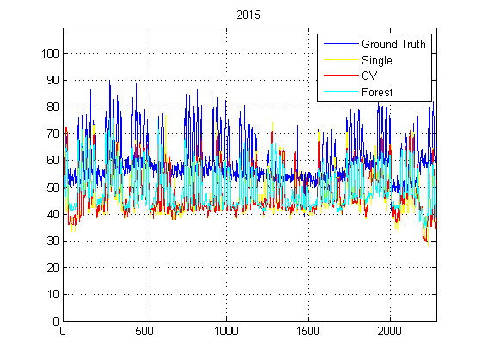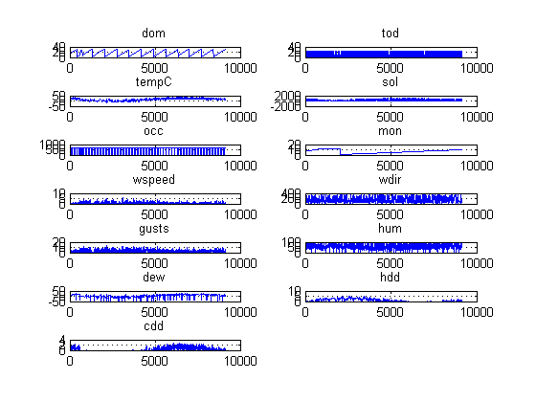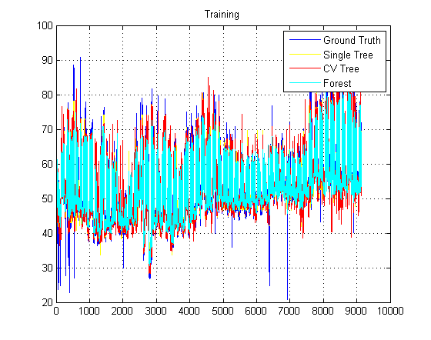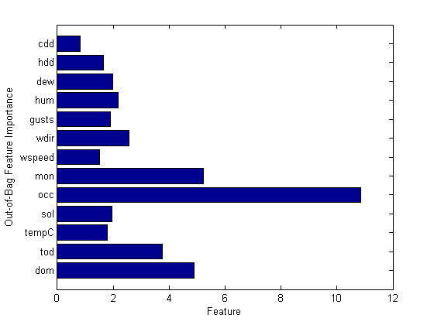

**Annenberg School Interpolated Old Data**

Learning Regression Tree...

Elapsed time is 0.328950 seconds.

Training RMSE(W): 5.01, R2: 0.813, RMSE/peak: 0.0454, NRMSD: 7.08

Learning a cross validated tree...

Elapsed time is 2.722156 seconds.

Cross Validated Training RMSE(W): 7.33, R2: 0.599, RMSE/peak 0.0665, NRMSD: 10.36

Learning a Random Forest...

Elapsed time is 96.523043 seconds.

Random Forests Training RMSE(W): 5.07, R2: 0.808, RMSE/peak 0.0460, NRMSD: 7.17

Testing RMSE(W): 18.71, R2: 0.000, RMSE/peak: 0.1698, NRMSD: 29.45

Cross Validated Testing RMSE(W): 17.44, R2: 0.000, RMSE/peak 0.1583, NRMSD: 27.45

RF (Testing) RMSE(W): 17.80, R2: 0.000, RMSE/peak 0.1616, NRMSD: 28.02

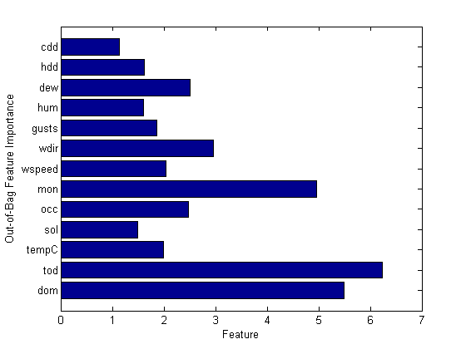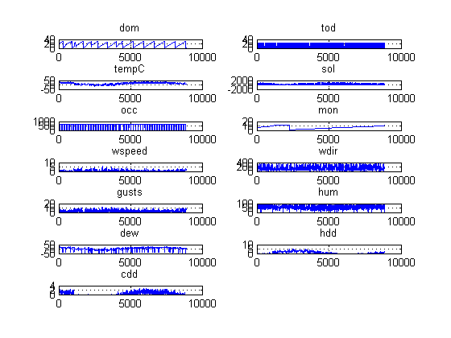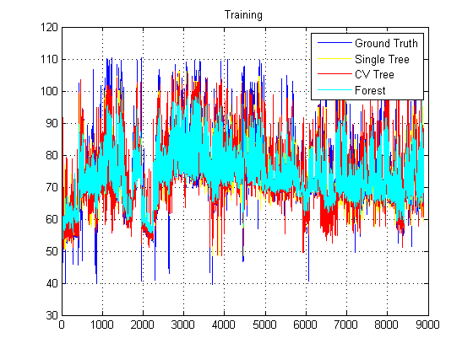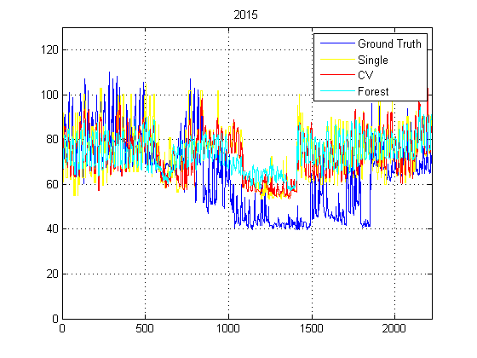

**Annenberg School Interpolated New**

Learning Regression Tree...

Elapsed time is 0.365187 seconds.

Training RMSE(W): 9.53, R2: 0.866, RMSE/peak: 0.0439, NRMSD: 7.02

Learning a cross validated tree...

Elapsed time is 3.245305 seconds.

Cross Validated Training RMSE(W): 14.81, R2: 0.677, RMSE/peak 0.0682, NRMSD: 10.91

Learning a Random Forest...

Elapsed time is 117.398976 seconds.

Random Forests Training RMSE(W): 10.23, R2: 0.846, RMSE/peak 0.0471, NRMSD: 7.54

Testing RMSE(W): 28.56, R2: 0.000, RMSE/peak: 0.1356, NRMSD: 20.30

Cross Validated Testing RMSE(W): 27.04, R2: 0.000, RMSE/peak 0.1284, NRMSD: 19.22

RF (Testing) RMSE(W): 22.65, R2: 0.000, RMSE/peak 0.1075, NRMSD: 16.10

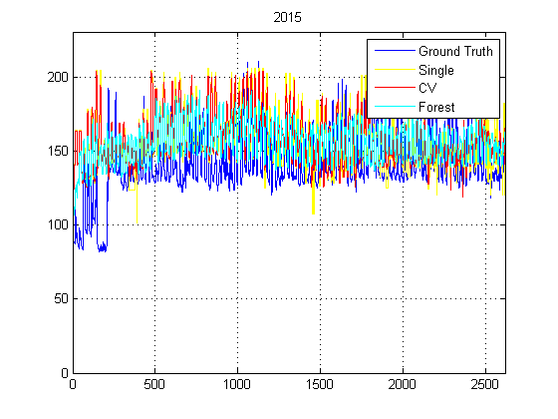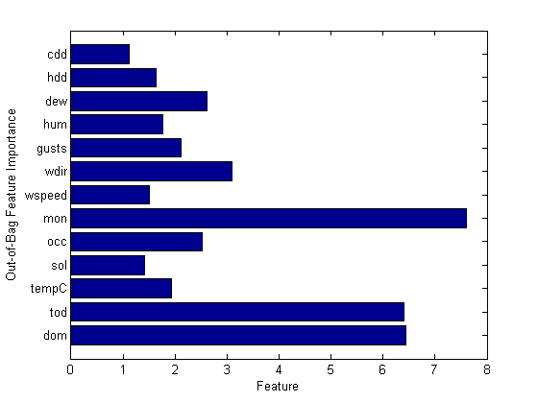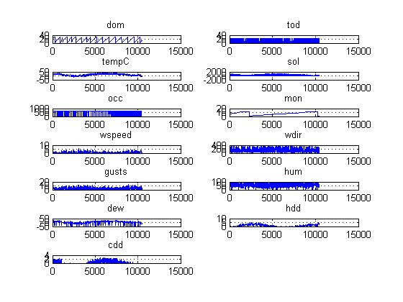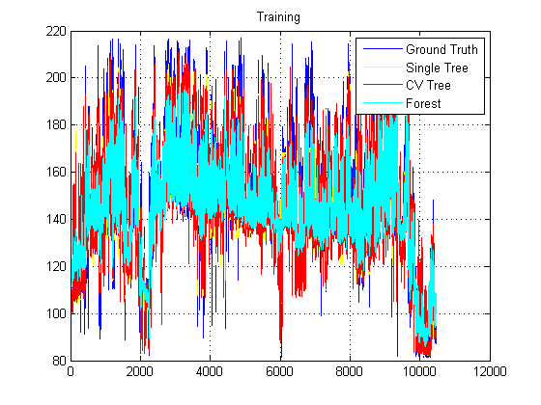

**Annenberg School Not Interpolated New Data**

Learning Regression Tree...

Elapsed time is 0.373793 seconds.

Training RMSE(W): 6.47, R2: 0.892, RMSE/peak: 0.0355, NRMSD: 4.73

Learning a cross validated tree...

Elapsed time is 3.295242 seconds.

Cross Validated Training RMSE(W): 9.79, R2: 0.753, RMSE/peak 0.0537, NRMSD: 7.15

Learning a Random Forest...

Elapsed time is 113.283701 seconds.

Random Forests Training RMSE(W): 6.63, R2: 0.887, RMSE/peak 0.0364, NRMSD: 4.84

Testing RMSE(W): 27.80, R2: 0.000, RMSE/peak: 0.1515, NRMSD: 22.09

Cross Validated Testing RMSE(W): 27.04, R2: 0.000, RMSE/peak 0.1474, NRMSD: 21.49

RF (Testing) RMSE(W): 26.80, R2: 0.000, RMSE/peak 0.1460, NRMSD: 21.30

